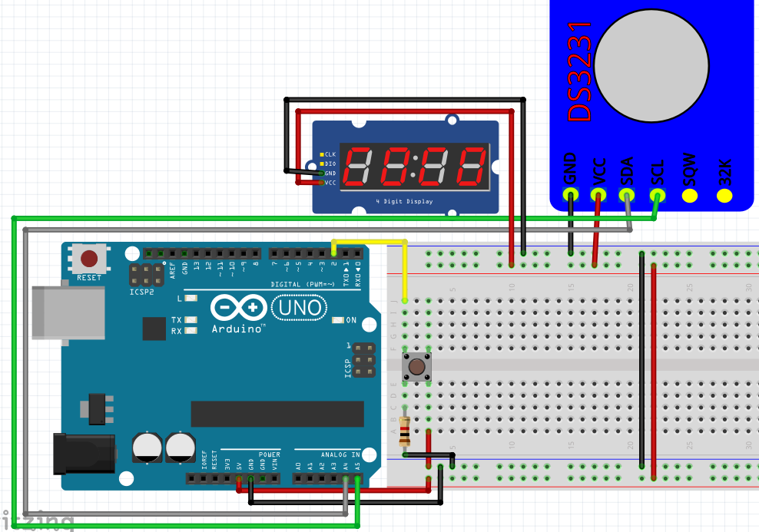

#include <DS3231.h>
#include <TM1637.h>
#include <Bounce2.h>
#define CLK 0
#define DIO 1
#define BTN 9

unsigned long int time, time1;
int hour = 0, min = 0, sec = 0, number;
String num, h, m, s;
int Day, Month, Year, date;
String Date, d, mo, y;
bool clock = true;
bool colon = false;

TM1637 tm1637(CLK, DIO);
DS3231 rtc(SDA, SCL);
Bounce btn = Bounce();

void setup() {
tm1637.init();
tm1637.setBrightness(5);
rtc.begin();

//rtc.setDOW(FRIDAY); // Set Day-of-Week to SUNDAY
//rtc.setTime(15, 19, 0); // Set the time to 12:00:00 (24hr format)
//rtc.setDate(1, 11, 2019); // Set the date to January 1st, 2014

pinMode(CLK, OUTPUT);
pinMode(DIO, OUTPUT);

pinMode(BTN, INPUT_PULLUP);

btn.attach(BTN);
btn.interval(5);

time = millis();
time1 = millis();
}

void loop() {

btn.update();

if (btn.fell()) clock = !clock;

if (clock) {
num = rtc.getTimeStr();

h = num[0];
h += num[1];

m = num[3];
m += num[4];

s = num[6];
s += num[7];

hour = h.toInt();
min = m.toInt();
sec = s.toInt();

if (millis() - time1 > 1000)
{
tm1637.switchColon();
colon = !colon;
time1 = millis();
}
number = hour * 100 + min;
tm1637.dispNumber(number);
}
else if(!clock){
Date = rtc.getDateStr();

d = Date[0];
d += Date[1];

mo = Date[3];
mo += Date[4];

y = Date[6];
y += Date[7];
y += Date[8];
y += Date[9];

Day = d.toInt();
Month = mo.toInt();
Year = y.toInt();

if(!colon) tm1637.switchColon();

date = Day * 100 + Month;
tm1637.dispNumber(date);
}
}
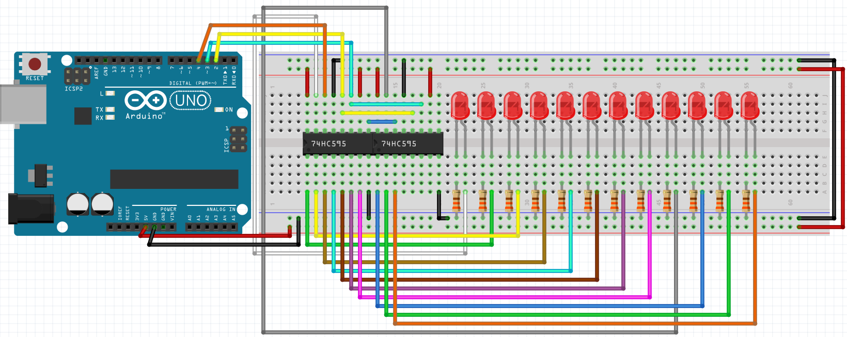

#include <HC595.h>

const int chipCount = 2;
const int clockPin = 15;
const int latchPin = 16;
const int dataPin = 17;

HC595 ledArray(chipCount, latchPin, clockPin, dataPin);

int lastPin = ledArray.lastPin() - 4;

void setup() {
ledArray.reset();
}

void loop() {
for (int i = 0; i <= 4095; i++)
{
for (int j = 0; j <= lastPin; j++) {
if (i & (1 << j)) ledArray.setPin(j, 1);
else ledArray.setPin(j, 0);
}
delay(25);
}

for (int i = 4095; i > 0; i--)
{
for (int j = 0; j <= lastPin; j++) {
if (i & (1 << j)) ledArray.setPin(j, 1);
else ledArray.setPin(j, 0);
}
delay(25);
}
}
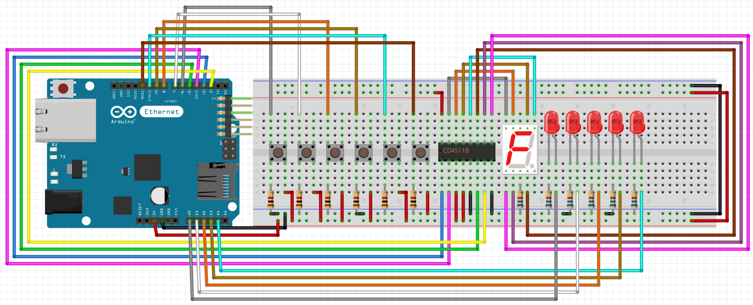

#include <SegmentDisplay_CD4511B.h>
#include <Bounce2.h>

SegmentDisplay_CD4511B CD4511(13, 14, 2, 3, 1);

#define LED1 4
#define LED2 5
#define LED3 6
#define LED4 7
#define LED5 8

int LEDS[] = {LED1, LED2, LED3, LED4, LED5};

#define BTN_1 9
#define BTN_2 10
#define BTN_3 11
#define BTN_4 12
#define BTN_5 15
#define BTN_6 16

Bounce btn1 = Bounce();
Bounce btn2 = Bounce();
Bounce btn3 = Bounce();
Bounce btn4 = Bounce();
Bounce btn5 = Bounce();
Bounce btn6 = Bounce();

unsigned long int time;

int Floor = 0;
int travel = 2000;
int next;

bool clicked[5];
bool Put = false;
int row[5];

bool up = true;
bool get_time = false;

int i;

bool reset = false;

void setup() {
for (i = 0; i < 5; i++) {
row[i] = -1;
}

pinMode(LED1, OUTPUT);
pinMode(LED2, OUTPUT);
pinMode(LED3, OUTPUT);
pinMode(LED4, OUTPUT);
pinMode(LED5, OUTPUT);

pinMode(BTN_1, INPUT_PULLUP);
pinMode(BTN_2, INPUT_PULLUP);
pinMode(BTN_3, INPUT_PULLUP);
pinMode(BTN_4, INPUT_PULLUP);
pinMode(BTN_5, INPUT_PULLUP);
pinMode(BTN_6, INPUT_PULLUP);

btn1.attach(BTN_1);
btn1.interval(5);

btn2.attach(BTN_2);
btn2.interval(5);

btn3.attach(BTN_3);
btn3.interval(5);

btn4.attach(BTN_4);
btn4.interval(5);

btn5.attach(BTN_5);
btn5.interval(5);

btn6.attach(BTN_6);
btn6.interval(5);

time = millis();
}

void loop() {
btn6.update();

if (btn6.fell()) {
if(!reset) reset = true;
else reset = false;
}

if (!reset) {
btn1.update();
btn2.update();
btn3.update();
btn4.update();
btn5.update();

if (btn1.fell()) {
clicked[0] = true;
sort(0);
}

if (btn2.fell()) {
clicked[1] = true;
sort(1);
}

if (btn3.fell()) {
clicked[2] = true;
sort(2);
}

if (btn4.fell()) {
clicked[3] = true;
sort(3);
}

if (btn5.fell()) {
clicked[4] = true;
sort(4);
}

ledsOn();
next = row[0];

if (next != -1) {
if (up) {
if (clicked[0] || clicked[1] || clicked[2] || clicked[3] || clicked[4]) {
if (!get_time) {
time = millis();
get_time = true;
}
}
if (millis() - time > travel) {
Floor++;
time = millis();
if (Floor == next) {
clicked[Floor] = false;
Move();
next = row[0];
}
}
}

if (!up) {
if (clicked[0] || clicked[1] || clicked[2] || clicked[3] || clicked[4]) {
if (!get_time) {
time = millis();
get_time = true;
}
}
if (millis() - time > travel) {
Floor--;
time = millis();
if (Floor == next) {
clicked[Floor] = false;
Move();
next = row[0];
}
}
}
}

if (!clicked[0] && !clicked[1] && !clicked[2] && !clicked[3] && !clicked[4]) {
get_time = false;
}

if (next > Floor) up = true;
else up = false;

CD4511.showNumber(Floor);
}
else
{
for (i = 0; i < 5; i++) {
row[i] = -1;
clicked[i] = false;
Floor = 0;
next = -1;
up = true;
get_time = false;
}
}
}

void sort(int num){
Put = false;
for(i = 0;i < 5;i++){
if(row[i] == -1 && Put == false){
row[i] = num;
Put = true;
}
}
bubbleSort();
}

void bubbleSort()
{
int j = 5, k;

while(j > 1)
{
for(k = 0; k < j - 1;k++)
{
if(row[k] < row[k + 1]) // 1 3
{
int pom = row[k]; // 1 3
row[k] = row[k + 1]; // 3 3
row[k + 1] = pom; // 3 1
}
}
j--;
}
}

void Move(){
row[0] = row[1];
row[1] = row[2];
row[2] = row[3];
row[3] = row[4];
row[4] = -1;
}

void ledsOn(){
for(i = 0; i< 5;i++){
if(clicked[i]){
digitalWrite(LEDS[i], HIGH);
}
else if(!clicked[i]){
digitalWrite(LEDS[i], LOW);
}
}
}

